
Headquarters - Procurement Department
225 North Pearl Street
Jacksonville, Florida 32202
October 29, 2025

ADDENDUM NUMBER: Two (2)
TITLE: Pole Line Hardware for JEA Inventory FY26 – FY31
JEA SOLICITATION NUMBER: 1412048646
BID DUE DATE: November 18, 2025
TIME OF RECEIPT: 12:00 PM
TIME OF OPENING: 02:00 PM
THIS ADDENDUM IS FOR THE PURPOSE OF MAKING THE FOLLOWING CHANGES OR CLARIFICATIONS:

- Changes:
ITEM ID: STAPL002
The following changes have been made to the list of approved manufacturers due to the staples not being barbed:

NOT APPROVED
CHANCE 9153
L&J INDUSTRIAL 1538162—C

APPROVED
ALLIED BOLT 22096
MACLEAN J7656

- Changes:
ITEM ID: STAPL003
The following changes have been made to the list of approved manufacturers due to the staples not being barbed:

NOT APPROVED
CHANCE 9154
L&J INDUSTRIAL 2050162-C

APPROVED
ALLIED BOLT 22099
MACLEAN J7672

- Changes: 1412048646 Addendum 2 Appendix B – Response Workbook is attached with the above changes highlighted on rows 660 and 661.

- Question: Do you have any information on why the Maclean DS-35M is not approved on this item?
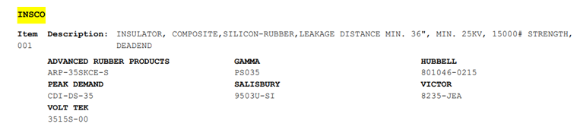

Answer: The Maclean deadend insulator was removed from standards because the width of the thimble-eye on the insulator was too wide for the clevis on our approved fiber extension (INSFE001 & INSFE002). The width of the thimble-eye needs to be less than .83 inches.

